Machine Description | BLUEMOON :2021 from VulnHub .BlueMoon is a boot2root CTF challenge available on VulnHub, designed to be of an easy difficulty level. The objective of the challenge is to obtain three flags as you progress towards gaining root access on the target machine
Target IP | 10.136.108.235
Vulnerability Name | Attacker can extract or brute-force credentials from exposed web resources.
Service / Version | TCP / 80 HTTP
CVSS Score / Severity | 9.8 Critical
Attack Vector | AV:N/AC:L/PR:N/UI:N/S:U/C:H/I:H/A:H
Proof Of Concept | STEP 1 – Discover Host IP address using Net discover tool  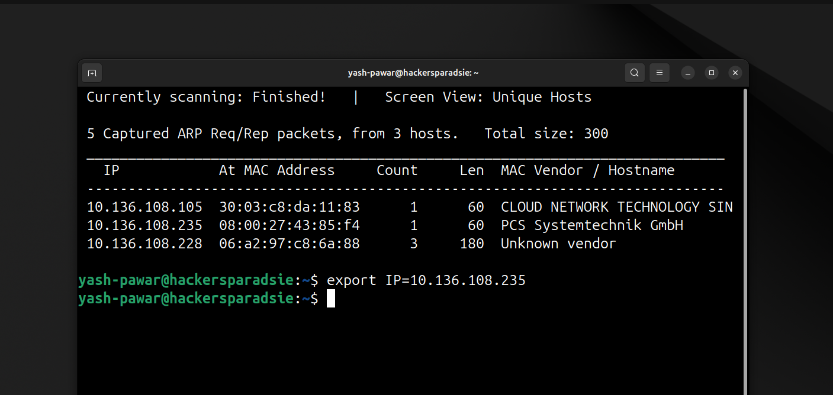  STEP 2 – Scan for Open ports and services on target using Nmap  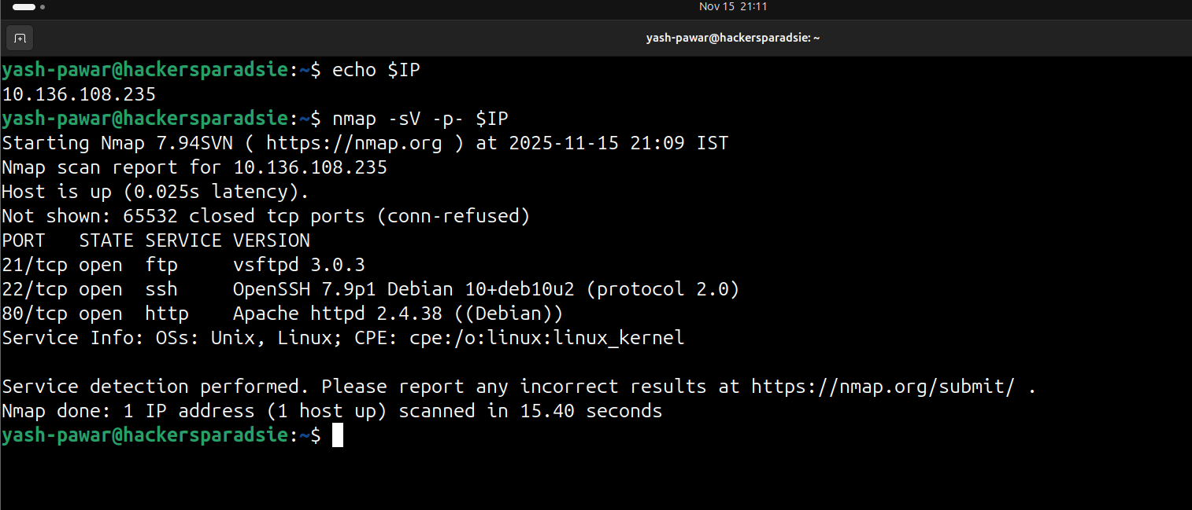  - Target is running 21, 22, 80 on system  STEP 3 – Enumerating HTTP 80  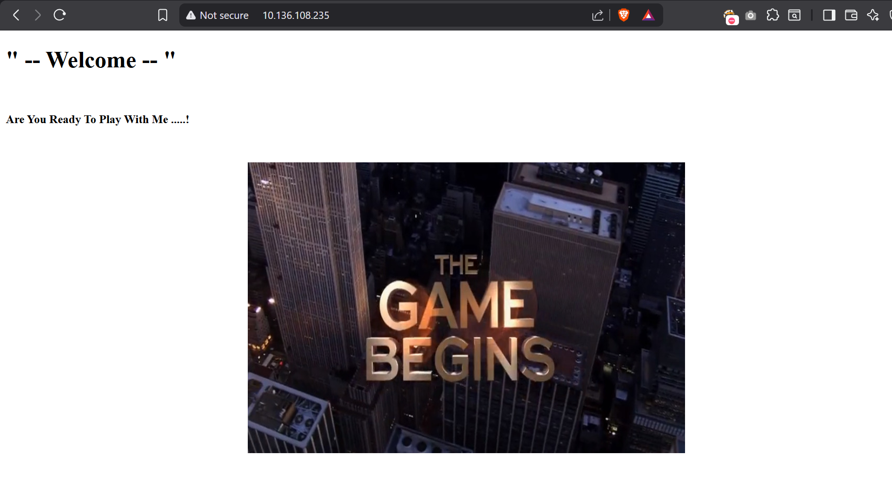  - Enumerating Directories we have hidden_text here  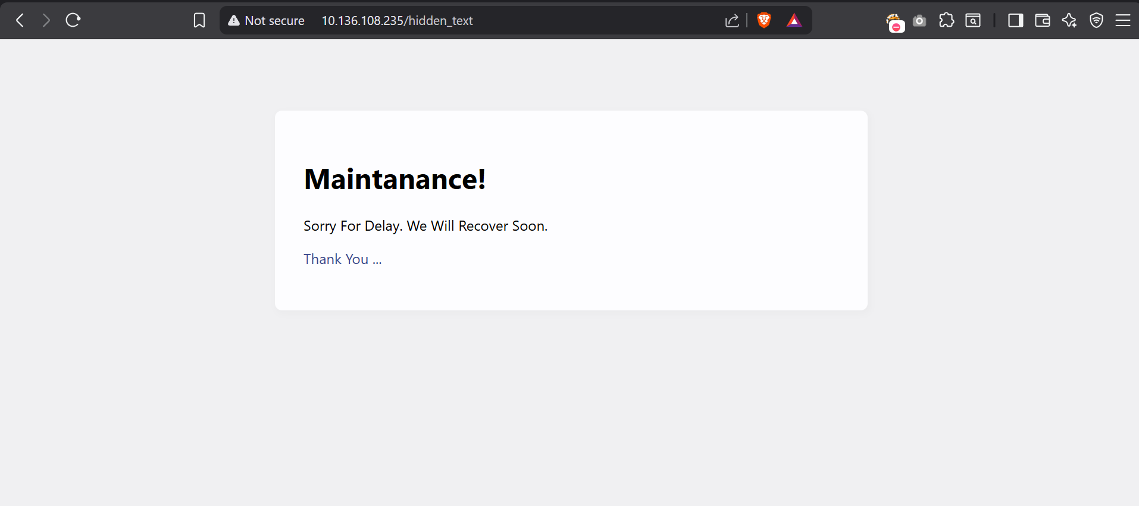  - There is one QR image lets download it  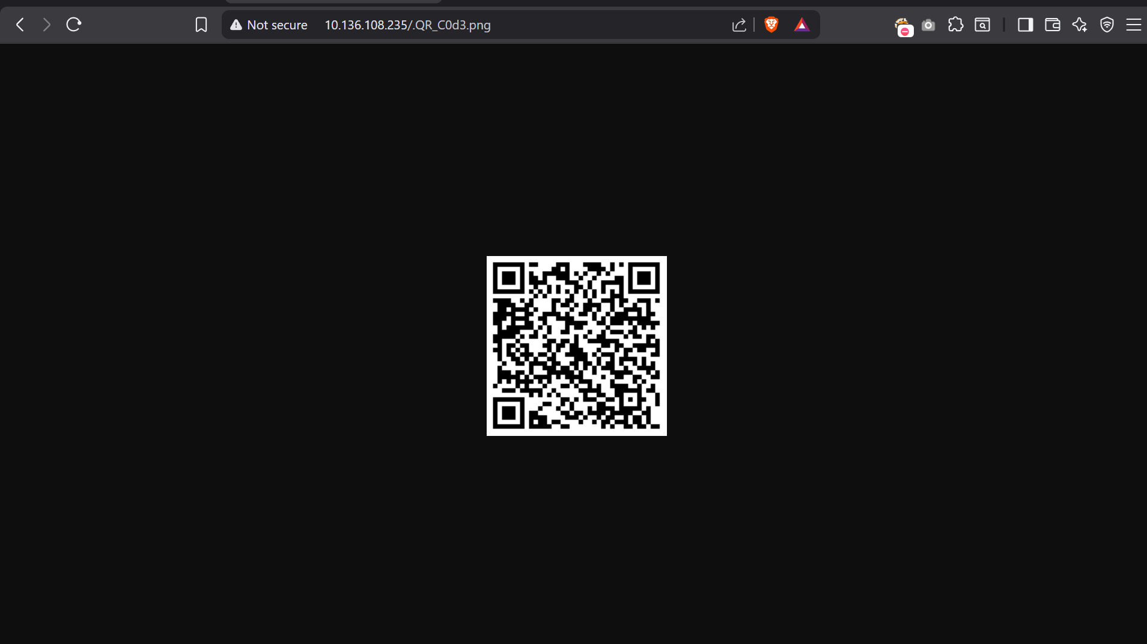  STEP 4 – Enumerate the QR we found creds for FTP login  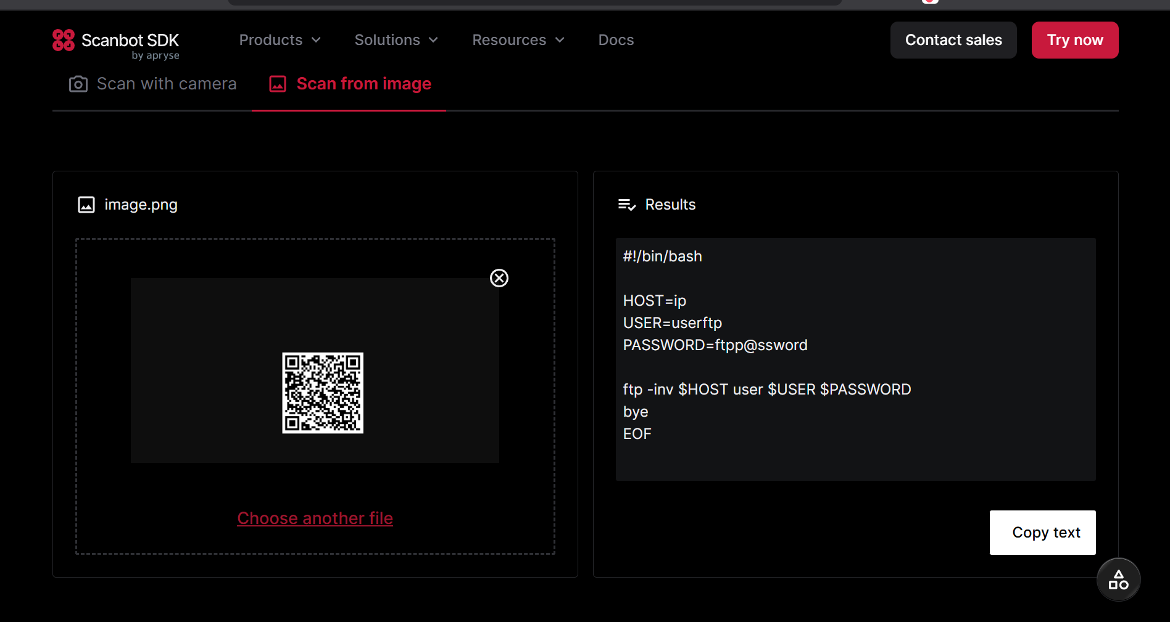  - Let’s authenticate with ftp  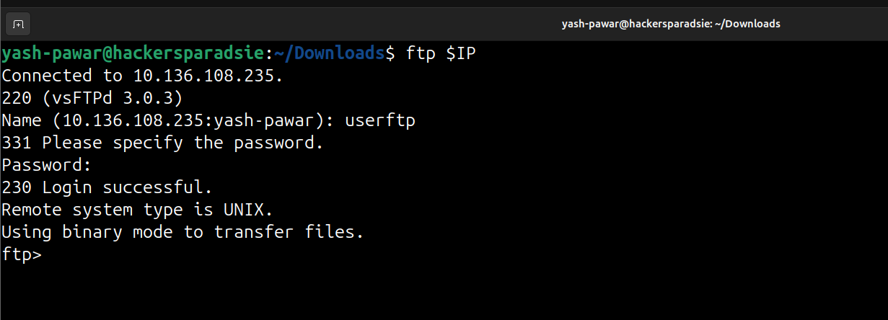  - Got FTP Login  STEP 5 – Enumerating FTP  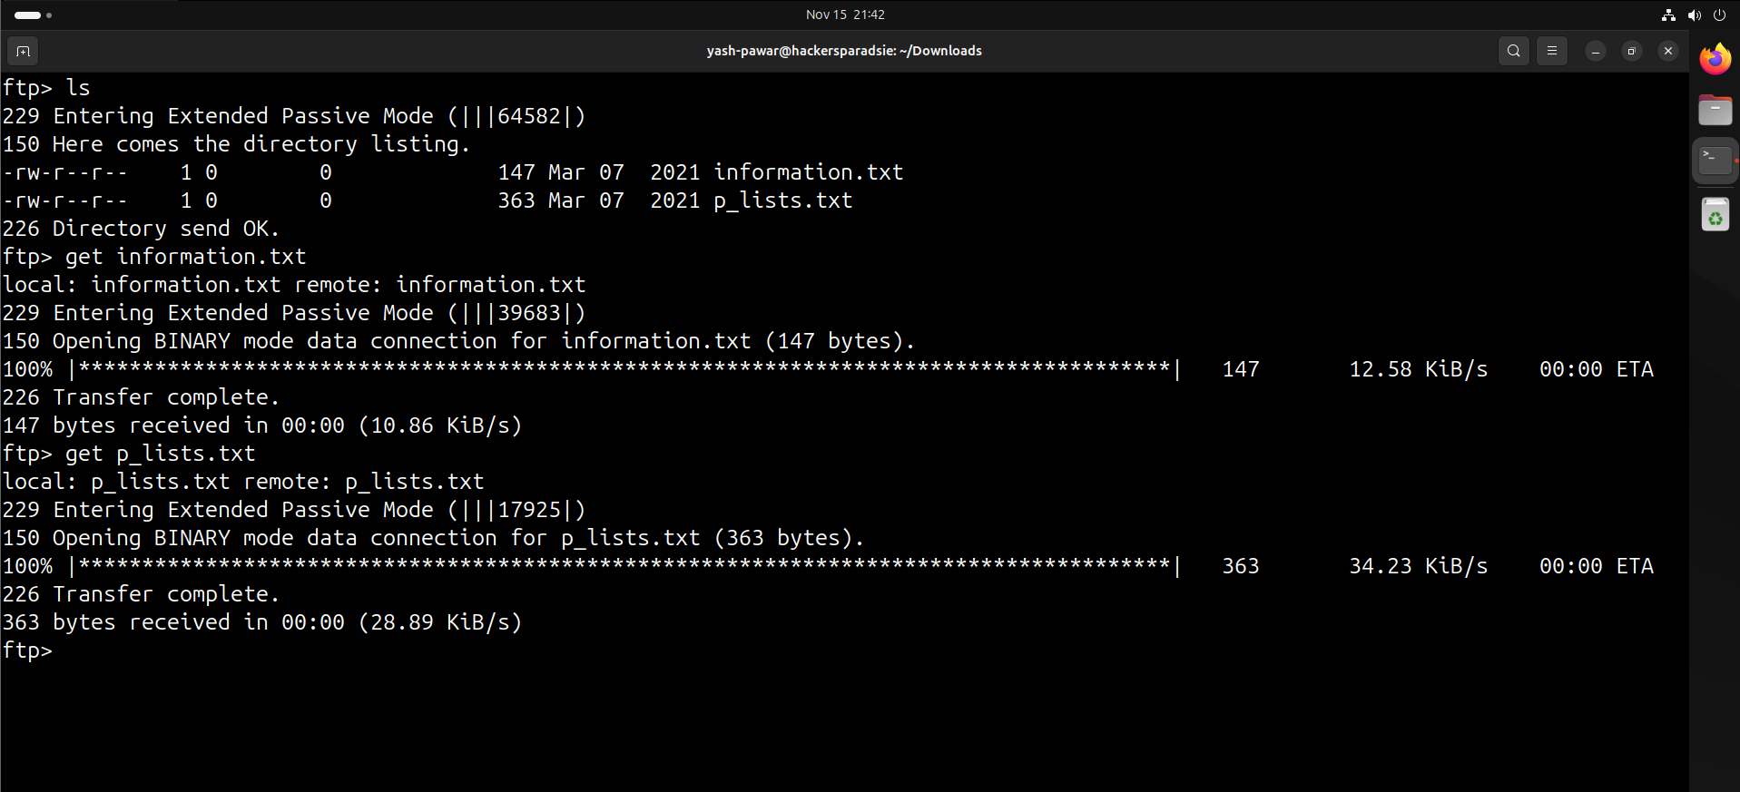  - We got two files let’s see what is inside it  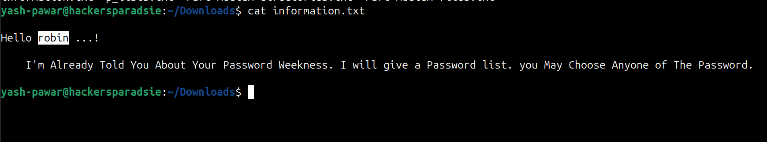  - We have user robin and we have password list  STEP 6 – Brute Forcing for SSH Credentials using Hydra  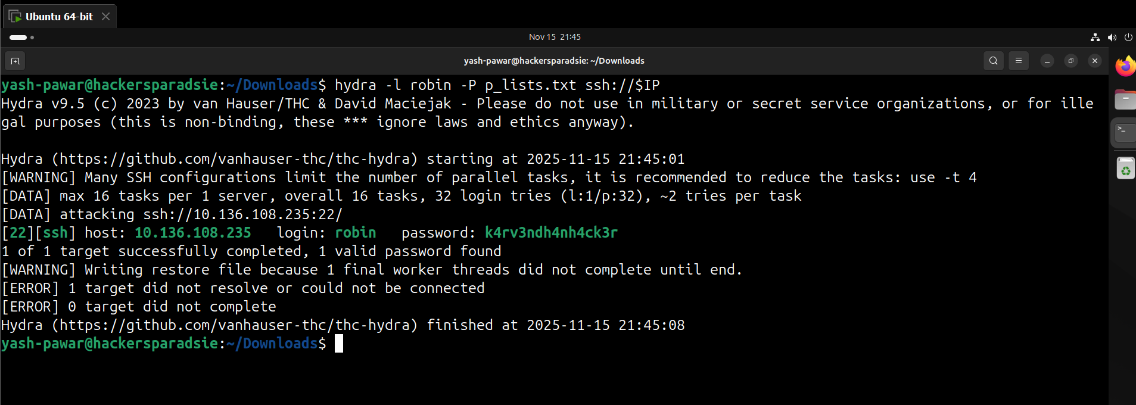  - Got valid creds lets authenticate got first flag here  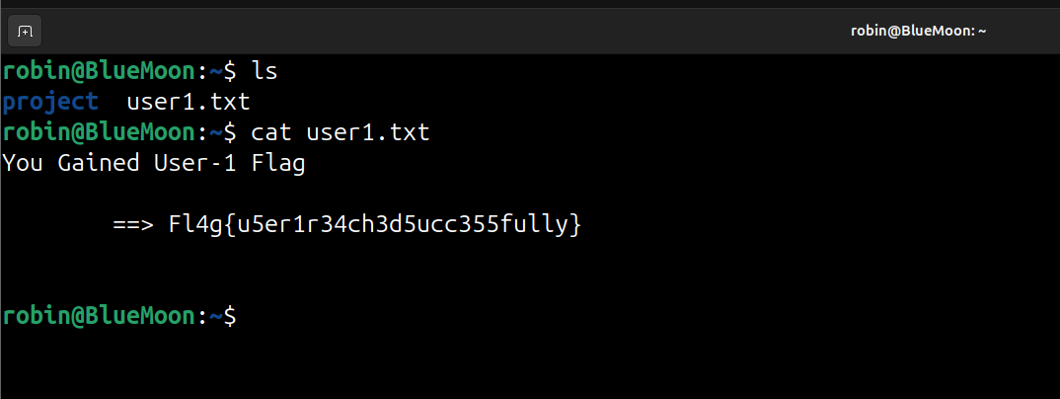  STEP 7 – Elevating Privilege  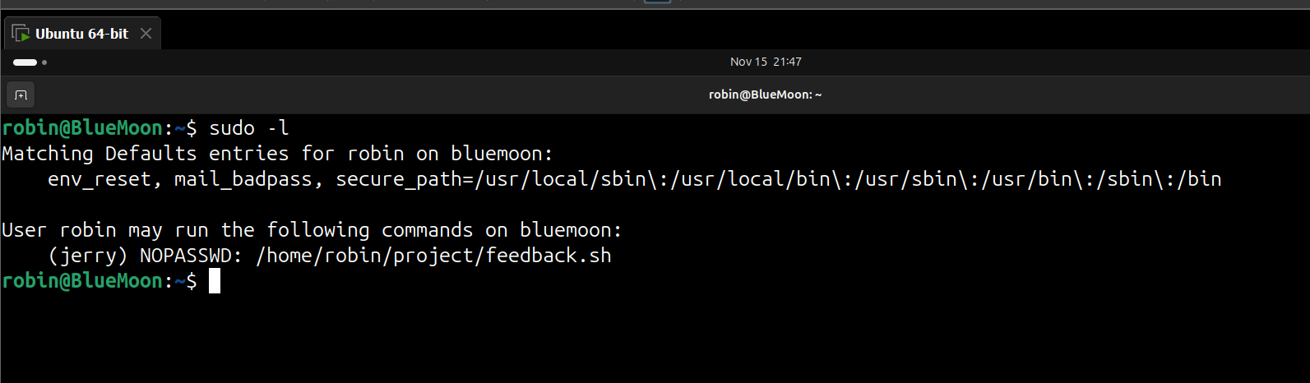  - Let’s try to access the mentioned file  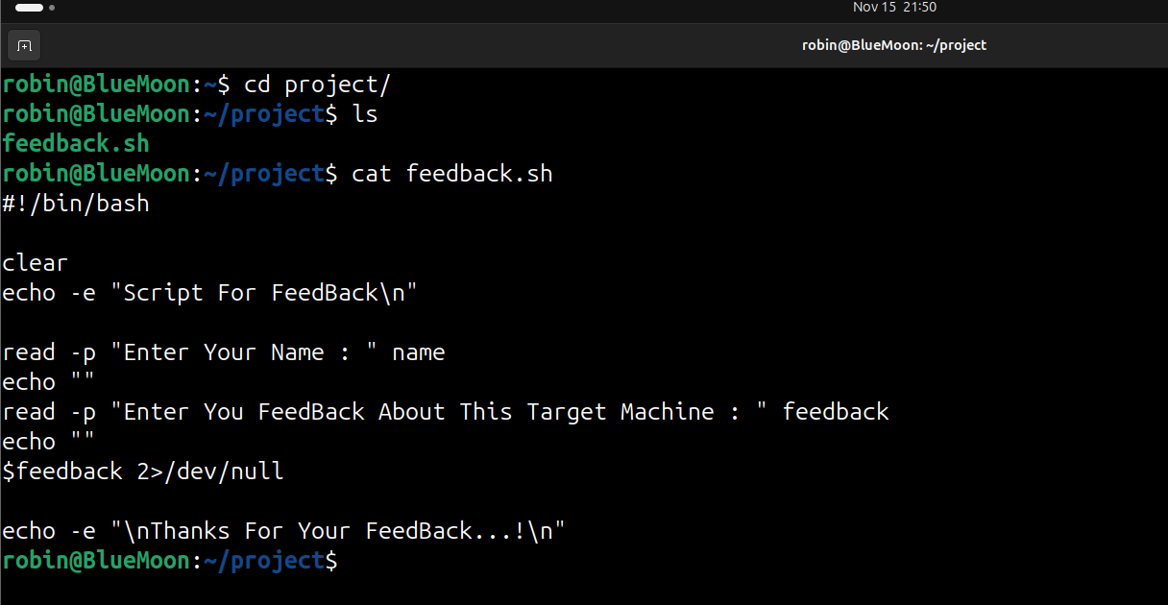  - Let’s try to run it and give feedback as /bin/bash  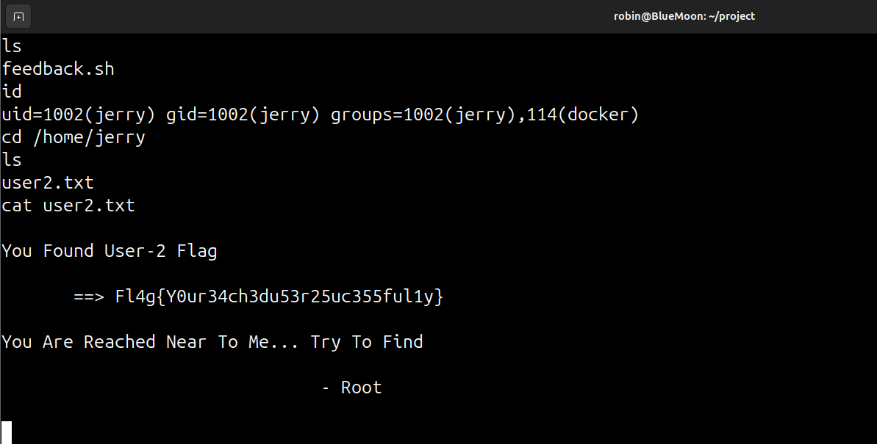  - We got Second flag and shell lets make shell interactive  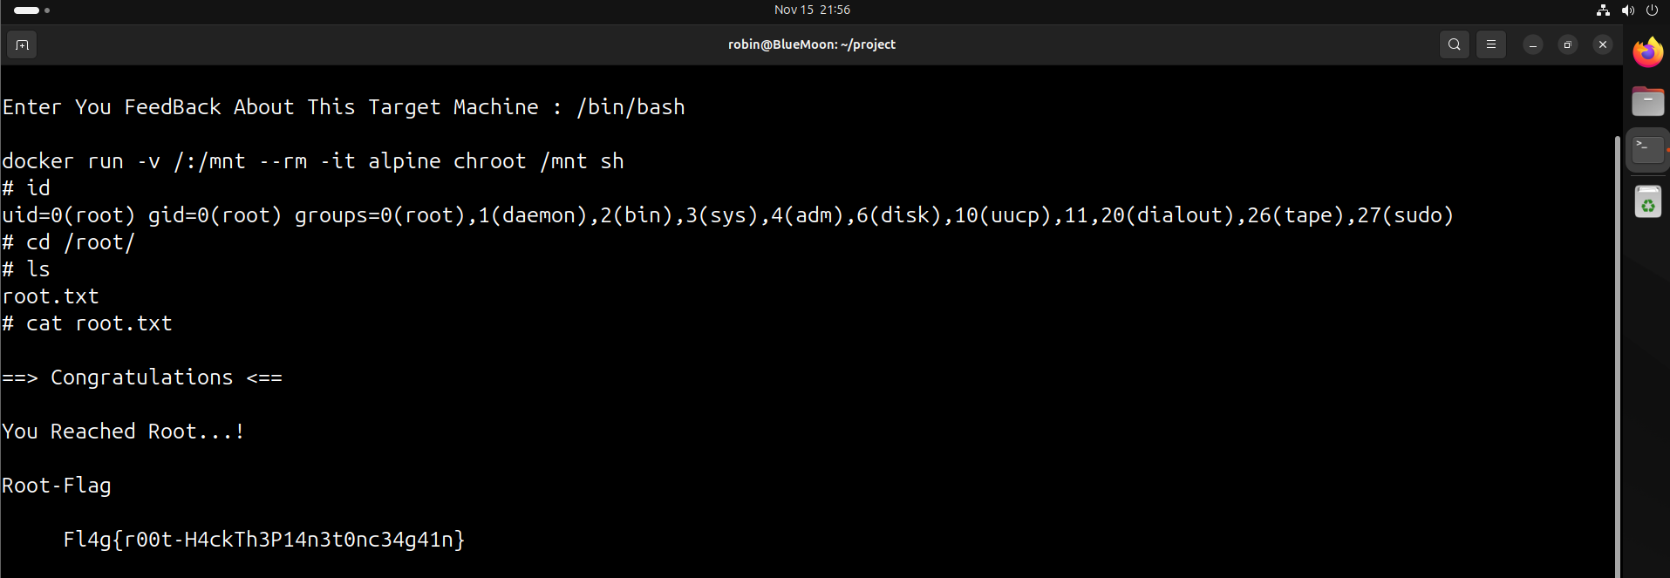  We got root on machine
Impact | - Attacker can extract or brute-force credentials from exposed web resources.  - Gaining SSH access allows lateral movement inside the system.  - Misconfigured sudo and Docker environment allow escape to host root.  - Full compromise of system integrity, confidentiality, and availability.
Remediation | - Remove exposed backup files, QR-encoded credentials, and directory listings.  - Enforce strong passwords, disable SSH password login, use SSH keys only.  - Patch and harden Docker; disable unnecessary containers; restrict runc permissions.  - Correct sudo policy, remove overly permissive commands, enforce least privilege.
Reference | https://nvd.nist.gov/vuln/detail/CVE-2019-5736  https://nvd.nist.gov/vuln/detail/CVE-2016-10033

